Taylor Stapus

CS 340

Module 5

03/28/2025

**Project One: CRUD in Python**

1. **Import CSV**

1. **Create aacuser account**

1. **Develop a Python Module**
2. **Method that Inserts a Document into a** **Specified MongoDB Database**
3. **Method that Queries for a Document from a Specified MongoDB Database**

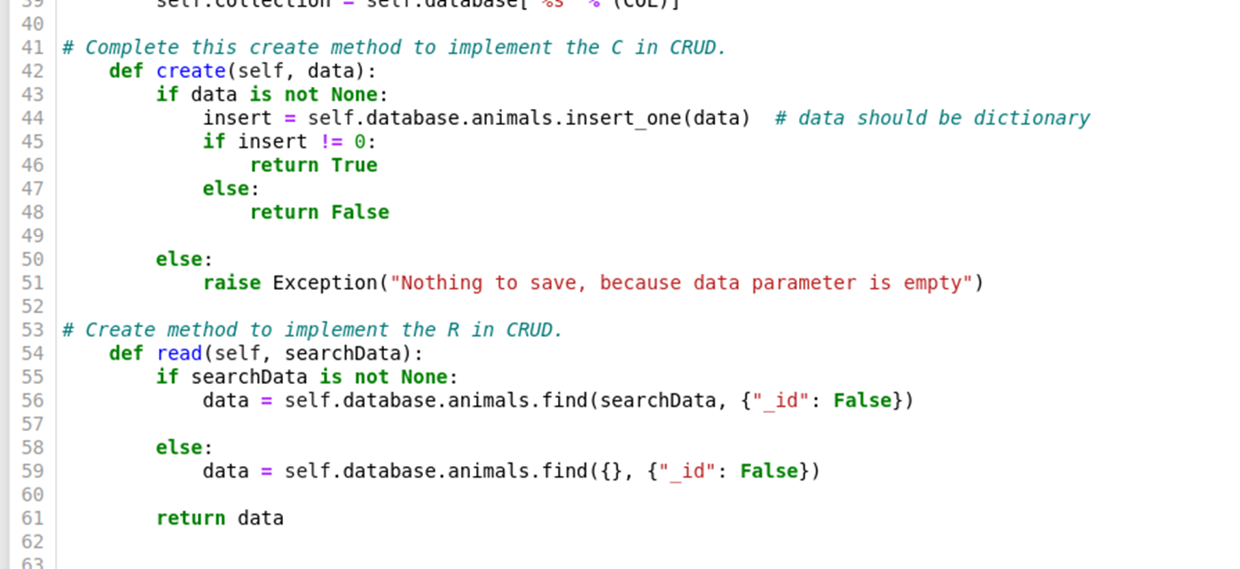

1. **Method that Updates and Changes Documents**
2. **Method that Deletes and Removes Documents**

1. **Testing Script in Jupiter Notebook**

